[我們的美國朋友]首頁畫面www.mrstina.com

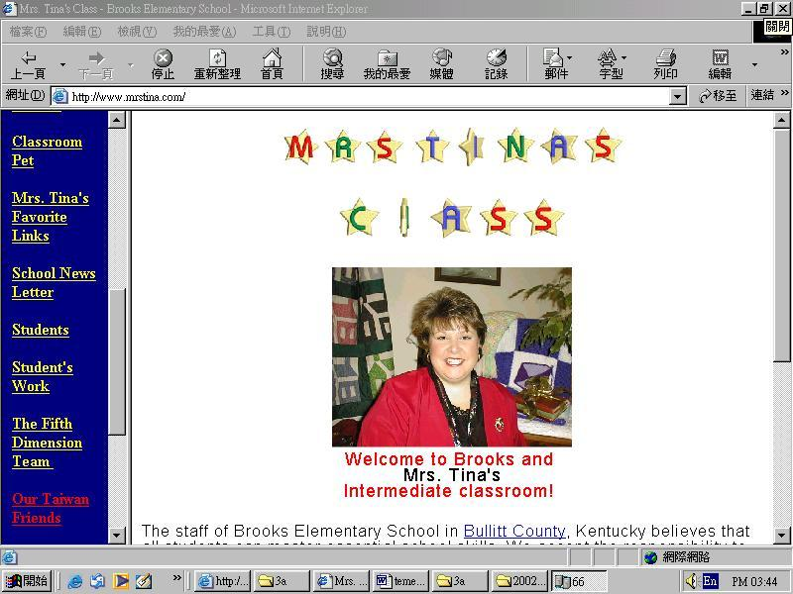

[三年級的美國朋友主題網站] http://ftp.tlps.cyc.edu.tw/~bird/3a/American%20friends/index.html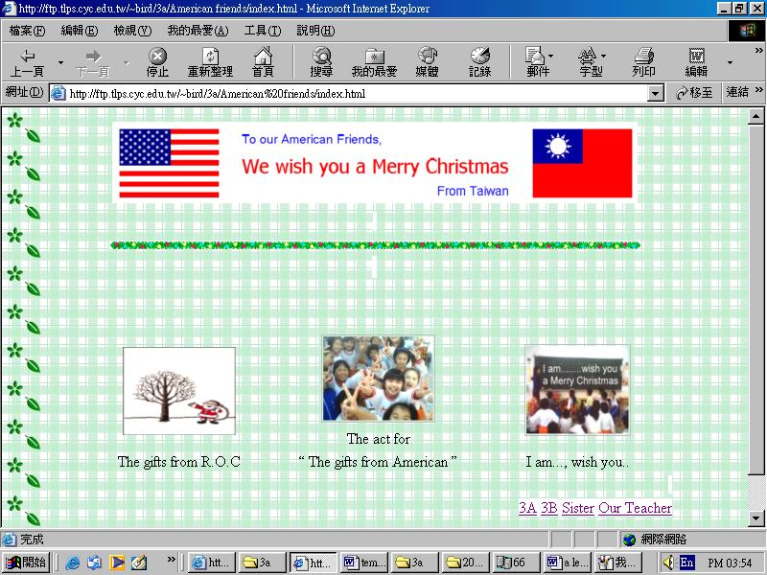
我們的美國朋友寄來的聖誕禮物說明
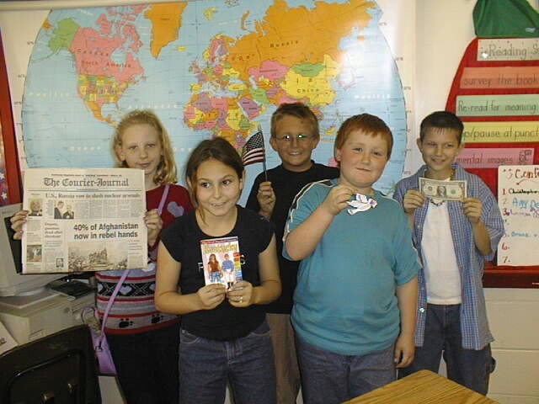Dear Friends, We would like to send you some items from America through the mail.
親愛的朋友們，我們想從美國郵寄下列這些東西給你們。
Can we send these items? If so, I need your mailing address.
不曉得好不好？如果可以的話，我需要你們的地址。以下是禮物的說明)
US money -美國錢幣-
one dollar bill worth one hundred cents.一張價值100分錢的一元鈔票
one quarter worth 25 cents.一張價值25分錢1/4元鈔票；
one dime worth 10 cents.一個價值10分錢的一角；
one nickel worth 5 cents一個價值5分錢的鎳幣；
one penny worth 1 cent而一個penny也就是1分錢。(還有)
I will send you a small version of our US flag. 我將寄一面小的美國國旗給你們。
Louisville Newspaper –(還有美國肯德基州)路易維耳市的報紙-
I am sending a book about our state of Kentucky. 還要寄一本介紹肯德基州的書-
I am sending your class a Christmas ornament. (另外)我要送給你的班級一個聖誕裝飾品。
It is a tradition to put ornaments on a Christmas tree.
在我們國家，將裝飾品掛在聖誕樹上是一項傳統。
Dove (bird) means "peace." 而我所寄的「鴿子」正代表著「和平」的意思。
Let me know if these items are appropriate to send, if not I will understand.
請你一定要讓我知道我們所郵寄的這些東西好不好，如果不是，我也會諒解。
Friends,Mrs.Tina 2001.11.11 美國朋友，緹納 2001.11.11

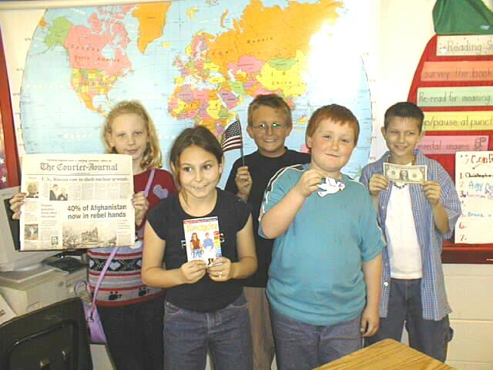

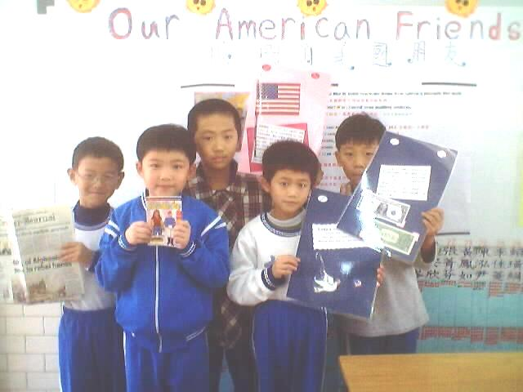

我的第一封自我介紹信及寄給美國朋友的聖誕禮物說明

Dear Mrs. Tina,


Since I heard that you and Mr. Shiu learn together by the internet，I have had great desire to learn with you. Let me introduce myself first. My name is Ko Bei Min. I am 23 years old. I am interested in reading, traveling, and listening to some music. Now ,I am a student teacher, and there are 31 students in my class（18 boys and 13 girls）. I think that this is a very special, significant and beautiful experience for me and my students！ Besides, I believe that we will enjoy learning and “traveling” with you. Moreover, we prepare some special Christmas presents for you. I’m not sure that these presents would be appropriate , but we all hope you would like these presents.

Our Christmas Present for you

1. The National Flag of ROC：
The core of the ROC flag - the white sun in a blue sky - was designed by the revolutionary Lu Hao-tun and publicly displayed for the first time at the founding of the Society for Regenerating China (Hsing-chung hui) in Hong Kong on February 21, 1895. A crimson background was added some years later. After the Northern Expedition established Republican rule throughout China in 1928, the flag was formally adopted by the ROC government.
The 12 points of the white sun represent the 12 two-hour periods into which Chinese people divide each day. This symbolizes unceasing progress. Blue connotes brightness, purity and freedom, red indicates fraternity, while white signifies honesty and equality.
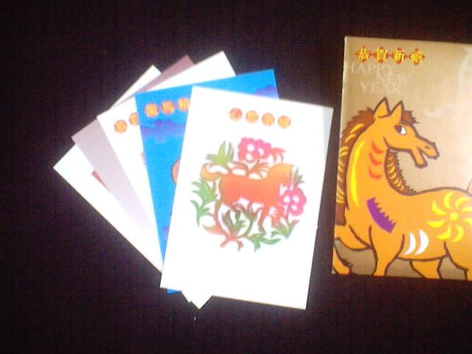
2. Domestic Postcards for New Year's Greeting：
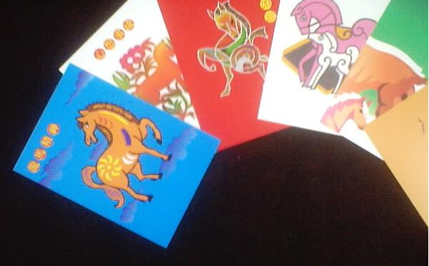
This set consists of twelve NT$2.50 denomination postal cards. Each postal card bears an indicium of the New Year’s Greeting Postage Stamps (Issue of 2001) in the upper left-hand corner. On the back of the 12 different postal cards are 12 representations of horse, chosen from the competition for the design of the New Year’s Greeting Postage Stamps, by 12 artists.
This year the Chinese lunar New Year falls on February 12, 2002. It is the ren-wu year (ren is the ninth of the Ten Celestial Stems and wu is the seventh of the Twelve Terrestrial Branches and signifies the year of the horse). The Chinese have traditionally used double-revolving combinations of the Ten Celestial Stems and the Twelve Terrestrial Branches to designate years. The full 60-year cycle is called a chia-tzu, for the first stem and first branch. The Twelve Terrestrial Branches also have animal representations: tzu (rat), chou (ox), yin (tiger), mao (rabbit), chen (dragon), szu (snake), wu (horse), wei (sheep), shen (monkey), yu (rooster), hsu (dog) and hai (pig). Each year the Directorate issues New Year's Greeting Postage Stamps taking the upcoming year's animal sign as the theme.

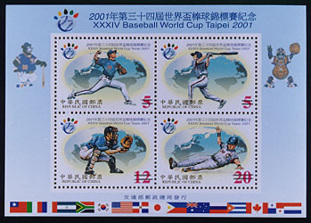
3. XXXIV Baseball World Cup Taipei 2001 Commemorative Issue Folder：

To help revive the sport of baseball in our country, President Chen has specially designated 2001 as Taiwan Baseball Year. To demonstrate the government's commitment to the promotion of baseball, Taiwan is holding three big international games this year. The games are the 21st Asia Baseball Tournament in March, the 4th Asia AAA Championship in August and the 34th Baseball World Cup in November. The latter will be the first international adult baseball games ever held in Taiwan, and 16 countries from around the world are sending teams. Since it is also the first "world cup" for baseball held during the 21st century, it is highly significant. To help expand the scope of "sports diplomacy," the Directorate is issuing a set of four stamps, "XXXIV Baseball World Cup Taipei 2001 Commemorative Issue." Each of the four stamps will feature a different figure from the baseball diamond, including a pitcher, a batter, a catcher and a sliding base runner.

4. XXXIV Baseball World Cup

Taipei 2001 Commemorative Issue FDC
5.The drawing that we made for you：
Since we received your
Christmas presents,
we have been very excited and happy.
So, my students “printed” their pictures
and drew their wishes on the papers for you.

6.The Christmas card that we made for you：
On the front cover：”We wish you a Merry Christmas” Between flags of U.S.A & R.O.C.
On the middle：”We wish you a Merry Christmas” Between childrens of U.S.A & R.O.C. Every body signed own name.
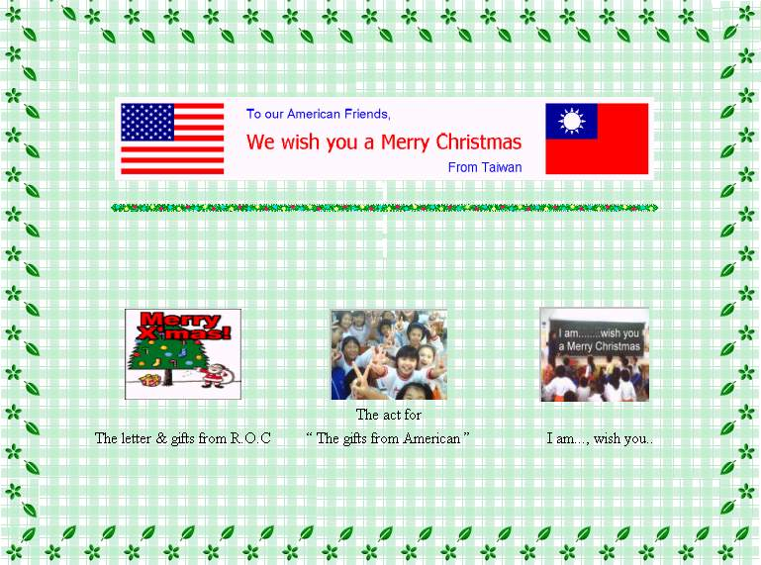
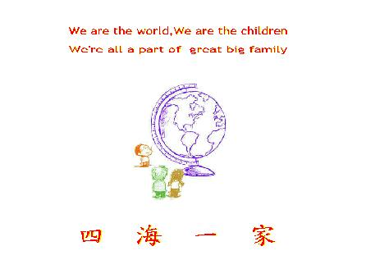
On the back cover：”We are the world….”

We wish you a Merry Christmas
我們祝你們聖誕節快樂

Hello! my dear American friends
Wish Mrs.Anderson
and every sutdents
Have a sweet Merry Christmas.

We wish you a Merry Christmas
We wish you a Merry Christmas
We wish you a Merry Christmas
And a Happy New Year

We are your Taiwan friends
Nice to meet you
It’s my honor to meet you
Keep in touch!

We wish you a Merry Christmas
We wish you a Merry Christmas
We wish you a Merry Christmas
And a Happy New Year

來，我們現在祝福我們美國朋友
(祝大家)祝你們大家聖誕節快樂

We wish you a Merry Christmas
We wish you a Merry Christmas
We wish you a Merry Christmas
And a Happy New Year
哈囉!親愛的美國朋友
祝福安德森老師
以及每一位小朋友
有一個甜蜜而快樂的聖誕節

我們祝你們聖誕快樂
我們祝你們聖誕快樂
我們祝你們聖誕快樂
還有新年快樂

我們是你們在台灣的朋友
很高興認識你們
認識你們是我們的榮幸
有空常聯絡喔！

我們祝你們聖誕快樂
我們祝你們聖誕快樂
我們祝你們聖誕快樂
還有新年快樂

來，我們現在祝福我們美國朋友
(祝大家)祝你們大家聖誕節快樂

我們祝你們聖誕快樂
我們祝你們聖誕快樂
我們祝你們聖誕快樂
還有新年快樂

